Project name: Amazon

Amazon.com is a vast Internet-based enterprise that **sells books, music, movies, housewares, electronics, toys, and many other goods**, either directly or as the middleman between other retailers and Amazon.com's millions of customers.

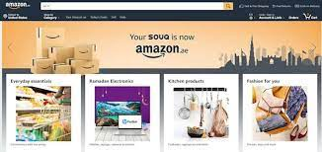

Top page (header):

Company logo,

location,

search bar,

flag(country),

sign in option,

orders

returns, cart.

Navigation bar:

Slide menu , bestsellers, mobiles, customer services ,prime ,electronics , todays deal , fastion , new releases, home & kitchen ,amazon pay ,computers , coupns, and toys and games.

The ad section: Advertisements and offers and banners section

Filters

* Sort by price
* User rating
* Price ranges
* Popular brands
* Discount
* Short high to low
* Short by colors
* Short by seller
* Availability
* Eligible pay on delivery

Item’s list

* Each item in separate division.
* Image of item and name
* Option to buy and add to cart
* Increase the quantity of item
* User rating
* Discount offers if available

PRODUCT DESCRIPTION - BRAND , PRODUCT DETAILS ,

SPECIFICATIONS , CUSTOMERREVIEWS .

Payment area:

After adding the item to the cart…the next page takes to payment side ,where you get sufficient payment options

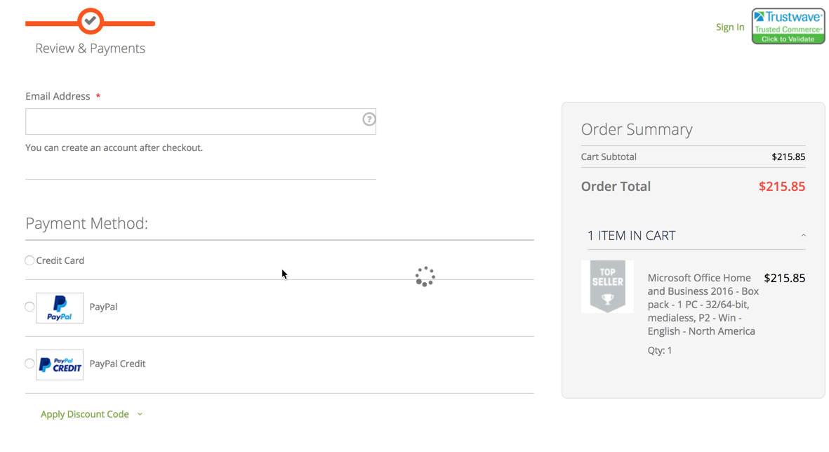

Thankyou..